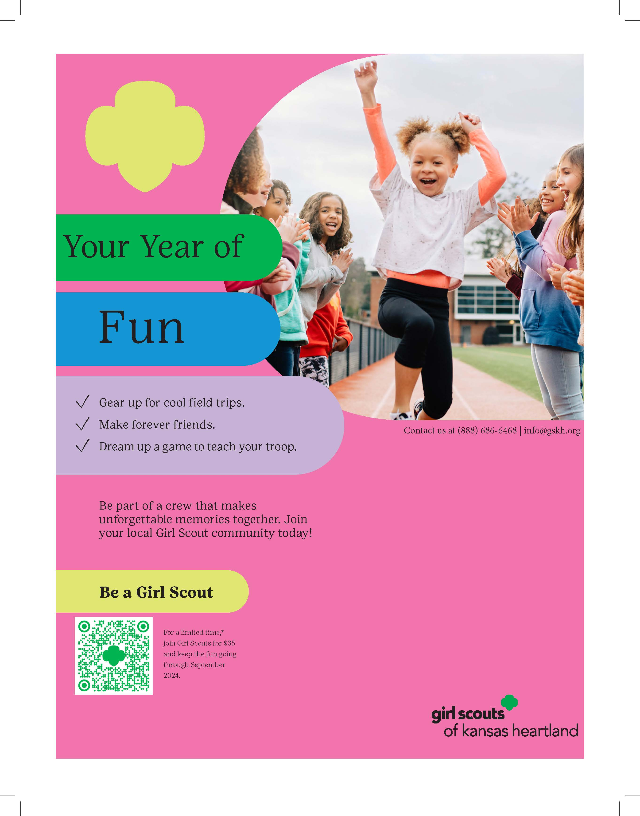

6:00 – 7:00 PM

April 11th

May 9th

May 30th

560 N. Park Ave, Valley Center

FUMC Room 8B